**UWWP Summit Page Step-By-Step and Troubleshooting**

Contents

Summit website address 1

Create your account and make a profile 1

Join event 2

Navigating each day’s content 4

Networking 4

Main stage 5

# Summit website address

**The main hub for the Summit will be visit** [**http://www.uwwp.org/nonprofit-leadership-summit/**](http://www.uwwp.org/nonprofit-leadership-summit/)

# Create your account and make a profile

**Before the start of the Summit, go to** [**http://www.uwwp.org/nonprofit-leadership-summit/**](http://www.uwwp.org/nonprofit-leadership-summit/) **to buy your ticket and create an account.**

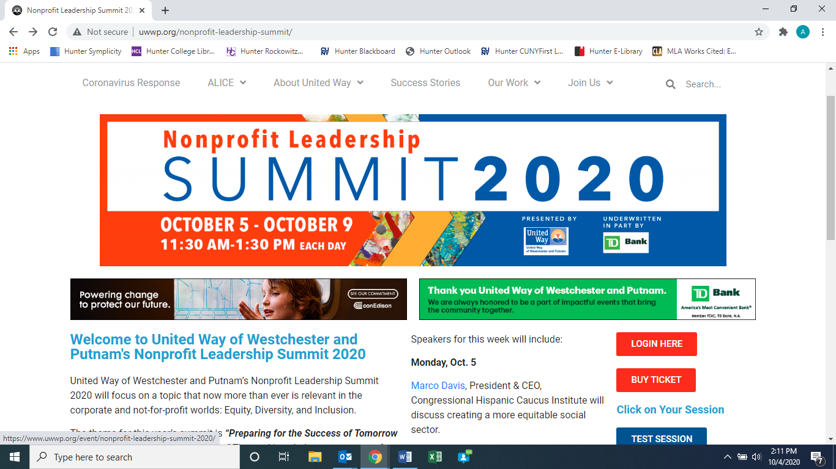

**You must select how many tickets you’d like to purchase before you’re able to proceed**

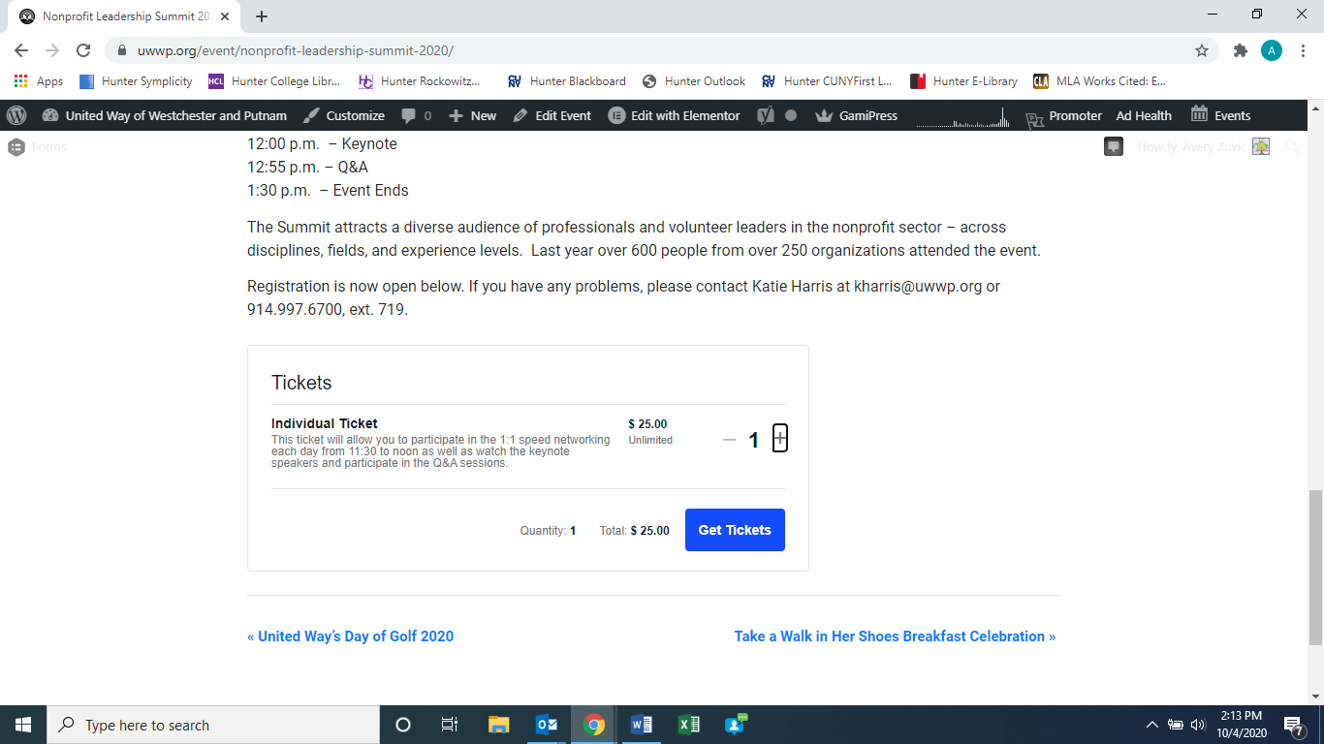

**The system will then allow you to create a profile.**

***We also suggest going to*** [***www.blitzr.com***](http://www.blitzr.com) ***and creating an account for the networking portion of the Summit ahead of time.***

# Join event

**At the date and time of a Summit session, visit** [**http://www.uwwp.org/nonprofit-leadership-summit/**](http://www.uwwp.org/nonprofit-leadership-summit/) **and log in.**



**Enter your username and password and click Login**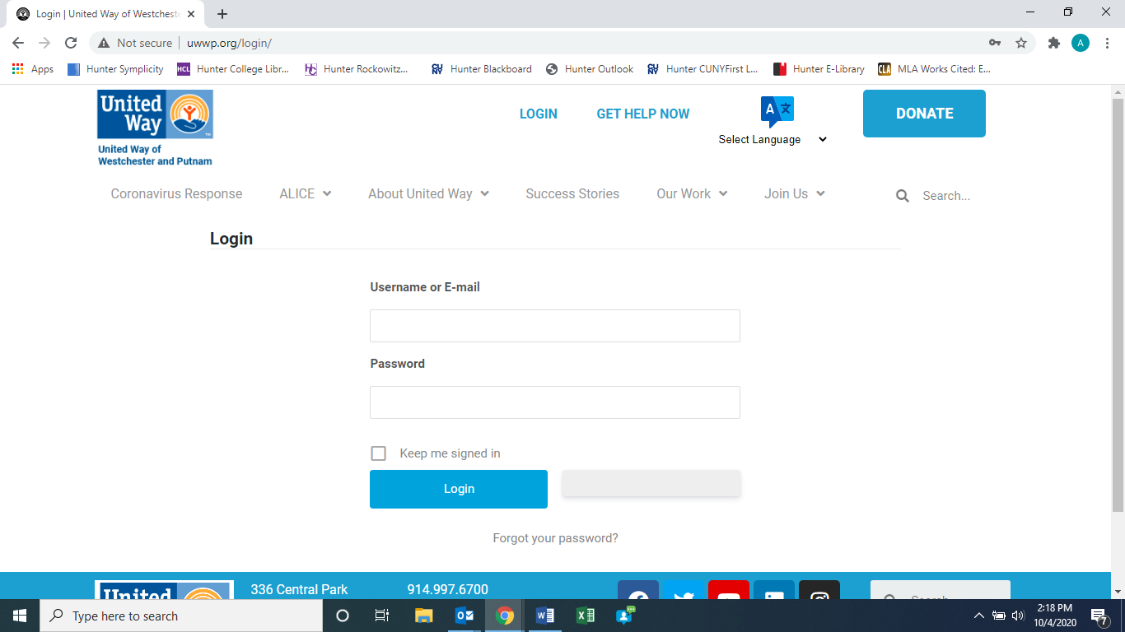

**①**

**②**

**Click on the button for that day’s session**

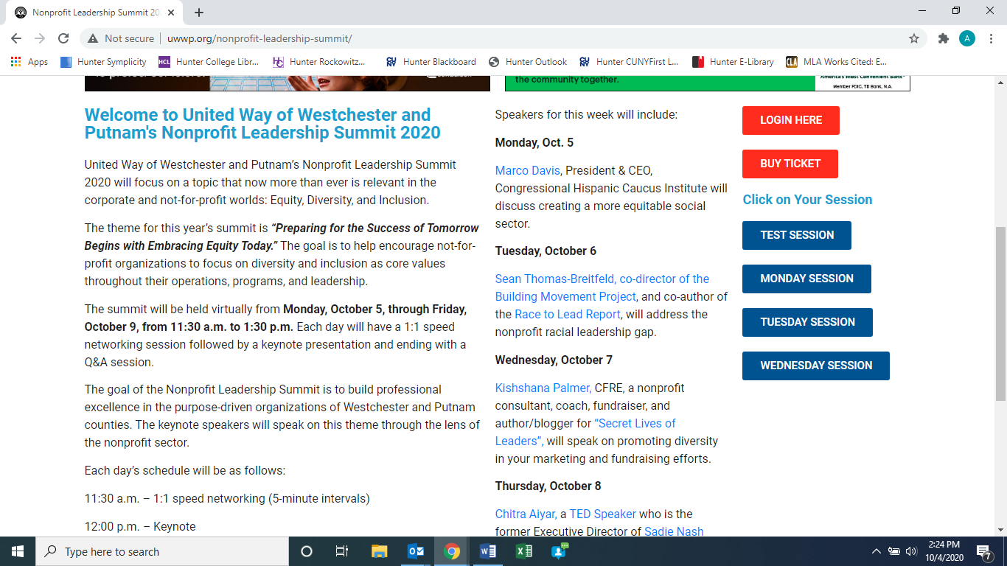

# Navigating each day’s content

Click the button for each part of the program or scroll down the page

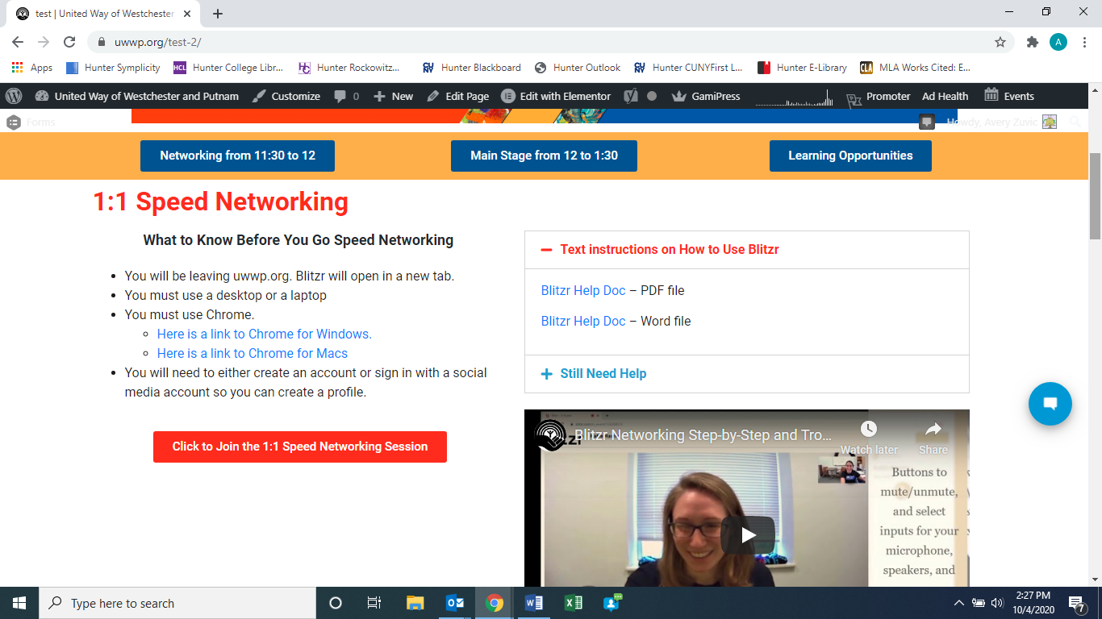

**Or scroll down**

# Networking

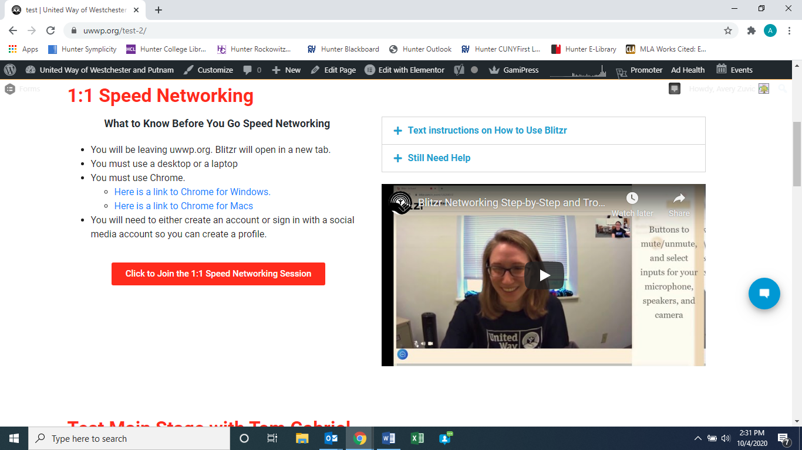

**Networking instructions & troubleshooting resources**

**Click to join networking**

# Main stage

The keynote presentation will appear in the main stage video once the event is live. If you’re having trouble viewing or hearing the presentation, try the following:

1. Refresh the page
2. Click “Live” at bottom left of video
3. Check the sound settings in the bottom right of the video and on your computer’s main volume control
4. Try using another browser. We suggest Chrome

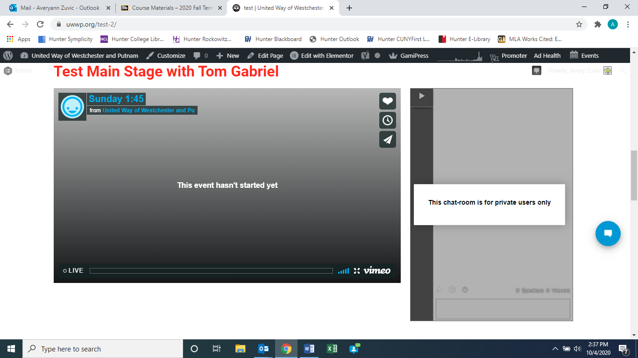

**Chat – ask questions and say hi!**

**Keynote presentation**

# Learning opportunities

The Fordham Graduate School of Social Service is teaming up with the United Way of Westchester and Putnam to offer continuing education credits for a fee to licensed social workers who complete the activities of each session of the Nonprofit Leadership Summit. The fee is $100 per module (2.5 CEs) or $400 for all five modules (12.5 CEs).

The course is also available to those interested in pursuing the topics covered in the Summit further at no additional cost.

