Blitzr Step-By-Step and Troubleshooting
Contents
System requirements 1
Create your account and make a profile 1
Join event 2
Test your video 3
Mic, speaker, and camera inputs 4

System requirements
Blitzr will only work on a desktop or laptop computer – NO MOBILE DEVICES
Blitzr is fully functioning on the Chrome browser. Other browsers will have limited function and performance. If you do not already have Chrome installed, you can download it here: https://www.google.com/chrome/

Create your account and make a profile
Before the start of the Summit, go to www.blitzr.com and create an account.

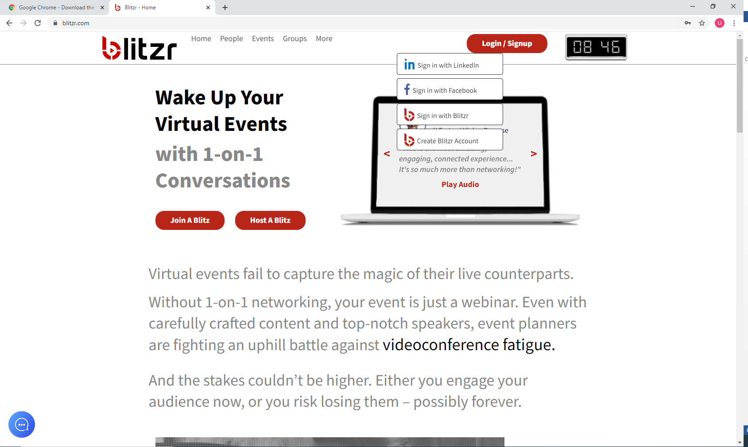

The system will then allow you to create a profile
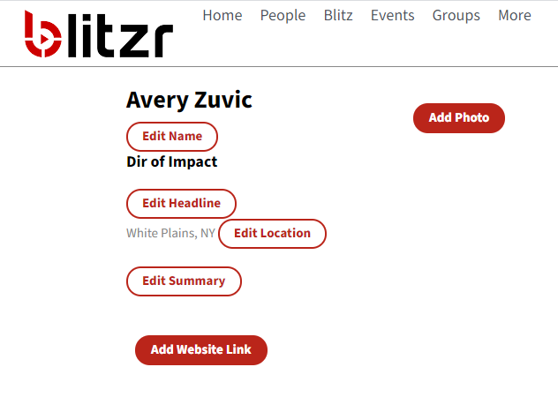

Join event
Use the link provided in the www.uwwp.org Summit page for today’s session
Click Join the Blitz
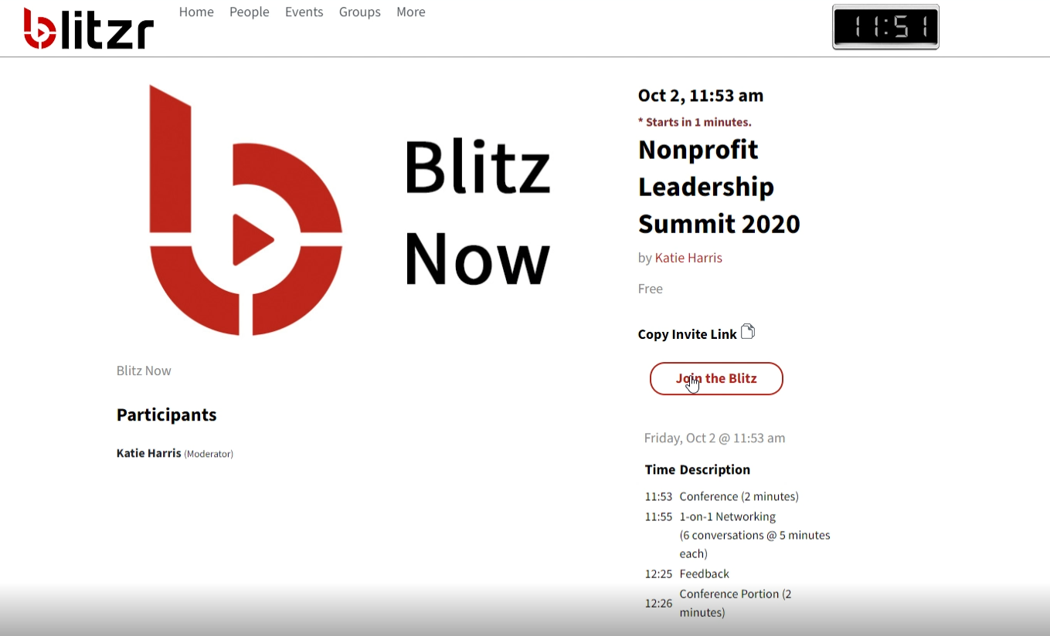

Click Sign In (whichever method you used to create your account) and click Login & Register, then click Join Event
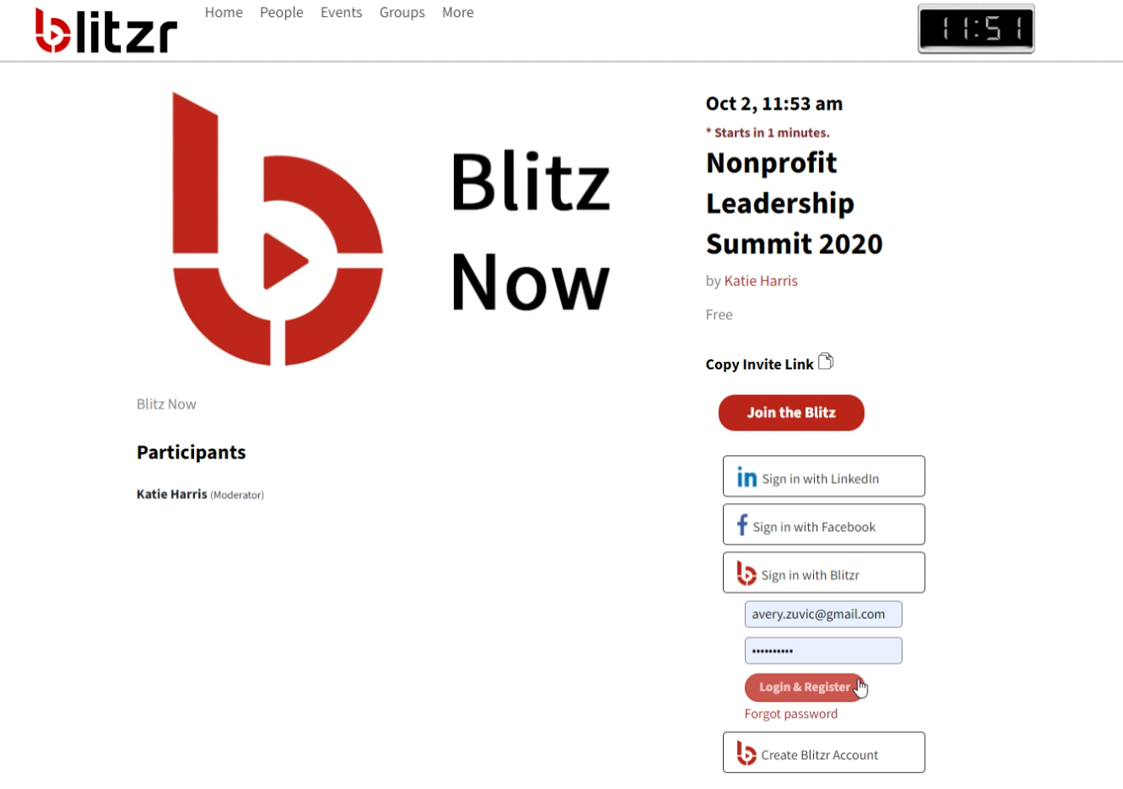

Test your video
Before the networking session begins, test you video
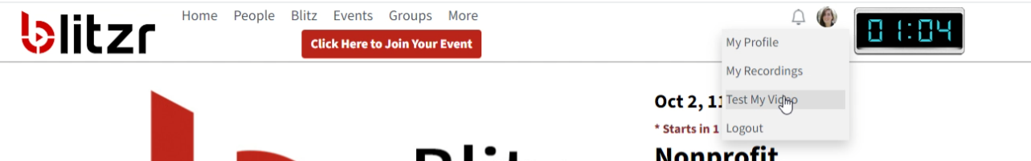

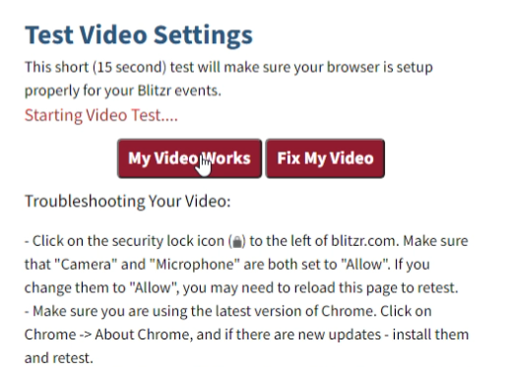
Click here for troubleshooting tips
Click here to start test

Mic, speaker, and camera inputs
Use the buttons in the bottom left of the video to mute/unmute, and to select inputs for your mic, speakers, and camera
